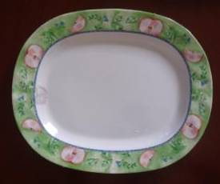 |  |  |  | 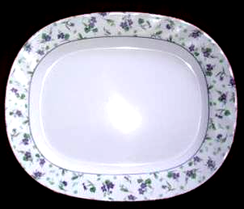
Y100415A 10” SQUARE PLATE- melamine, w/printing design on edge, one pattern & color. Weight: 75 g/pc. Packing: 100 pcs/ctn/0.0235 cbm/0.83 cuft.  Q’ty: 65,000 pcs (650 ctns)  FOB US$0.14/pc |  |  |  | Y100415B 12” SQUARE PLATE- melamine, w/printing design on edge, one pattern & color. Weight: 105 g/pc. Packing: 72 pcs/ctn/0.0225 cbm/0.80 cuft.  Q’ty: 10,800 pcs (150 ctns)  FOB US$0.19/pc
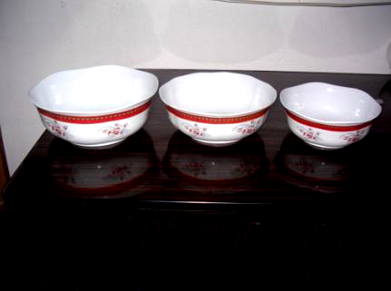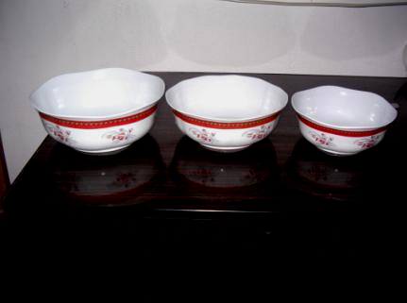 |  |  |  | 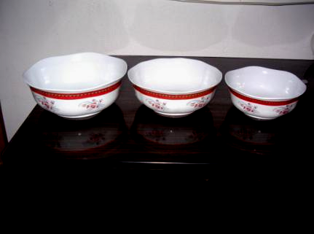
Y100415C 7” BOWL- melamine, w/printing design around the bowl, weave edge. one pattern & color. Weight: 120 g/pc. Packing: 72 pcs/ctn/ 0.025 cbm/0.88 cuft.  Q’ty: 6,480 pcs (90 ctns)  FOB US$0.26/pc |  |  |  | Y100415D 9” BOWL- melamine, w/printing design around the bowl, weave edge. one pattern & color. Weight: 165 g/pc. Packing: 36 pcs/ctn/ 0.0257 cbm/0.91 cuft.  Q’ty: 2,160 pcs (60 ctns)  FOB US$0.32/pc
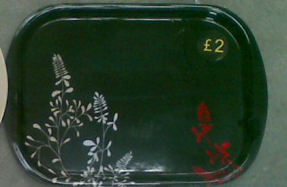 |  |  |  | 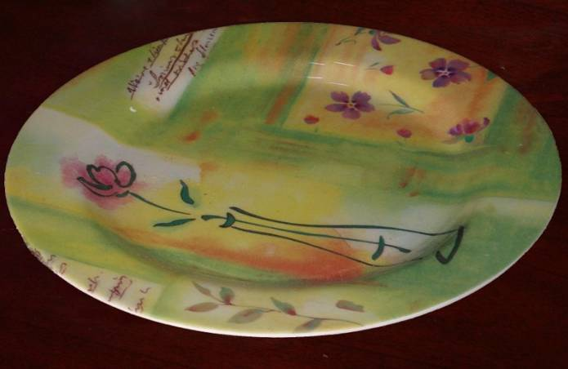
Y100415E 13” TRAY- melamine, w/printing design, one pattern & color. Weight: 250 g/pc. Packing: 48 pcs/ctn/0.0245 cbm/0.87 cuft.  Q’ty: 2,880 pcs (60 ctns)  FOB US$0.43/pc |  |  |  | Y100415F 10” ROUND PLATE- melamine, w/printing design, one pattern & color. Weight: 75 g/pc. Packing: 120 pcs/ctn/0.025 cbm/0.87 cuft.  Q’ty: 7,200 pcs (60 ctns)  FOB US$0.15/pc
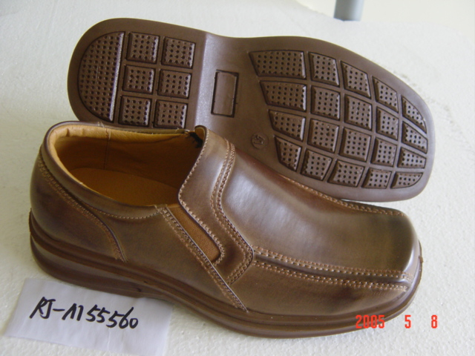  #M55560 Black 537 ctns (6,444 prs), brown 239 ctns (2,868 prs). |  |  |  | 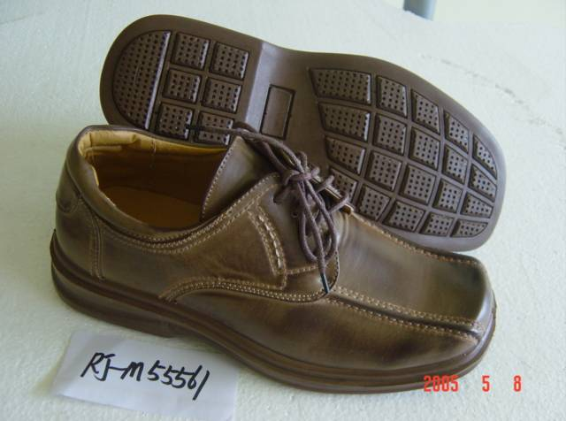  #M55561 Black 1,383 ctns (16,596 prs), brown 240 ctns (2,880 prs).
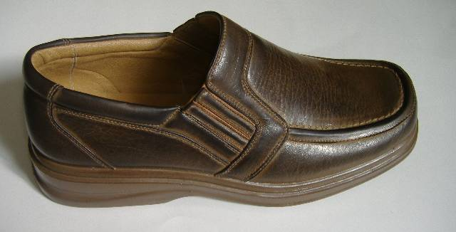  # M55592 Brown 478 ctns (5,736 prs). |  |  |  | 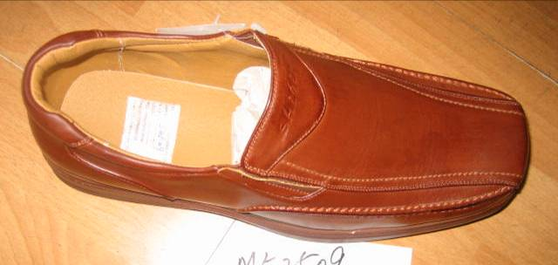  #M52509 Black 412 ctns (4,944 prs), brown 77 ctns (924 prs).
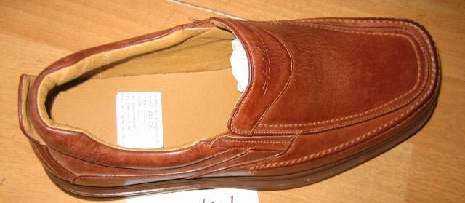  #M52501 Black 149 ctns (1,788 prs), brown 30 ctns (360 prs). |  |  |  | 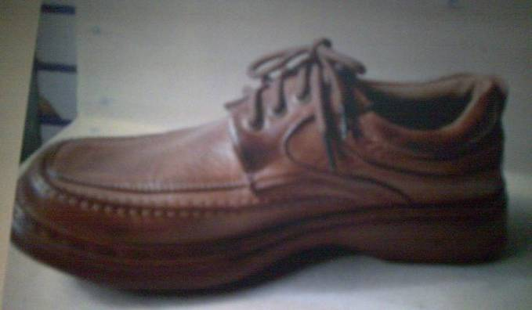  # M52503 Black 67 ctns (804 prs).
I/NO. |  |  | Y100414-M55560, M55561,… | Stock Q’ty: | 43,344 prs (3,612 ctns)
Description |  |  | MAN’S CASUAL SHOES- PU sole, PU napa leather upper, PVC inner sole. All are matching color. 6 dift. patterns, 2 colors of black & brown. Logo of “SHILIN”. Size range /ratio:  - 41 42 43 44 45 46  1 2 2 2 2 2 1 =12 | Packing: | each pr packed in a Poly bag and individual box. 12 prs (boxes) in a carton (abt. 0.054 cbm/1.90 cuft.)
FOB US$ (NINGBO) |  |  | 5.80/pr | Remarks:
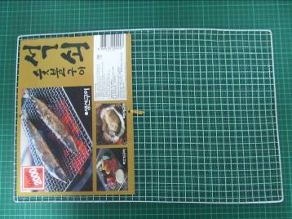 |  |  |  | 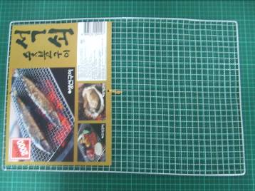
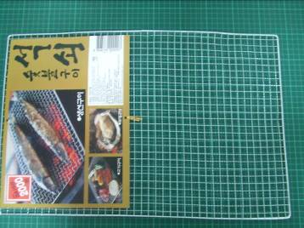 |  |  |  | 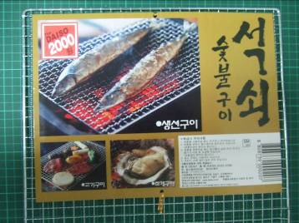
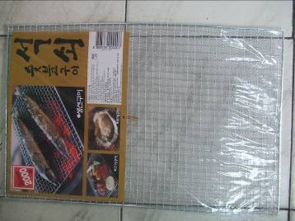 |  |  |  | 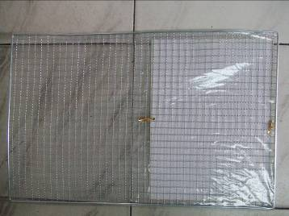
Y100409 BAR-B-Q GRILL- metal mesh net, size: L.50.5xW.32.5 cm. Each pace packed in a OPP bag w/color paper insert. Packing: 12 pcs in a inner box, 4 boxes (48 pcs) in a carton (53x34x26 cm/0.047 cbm/1.65 cuft.).
Q’ty: 9,600 pcs
FOB US$0.36/pc . .
 |  | 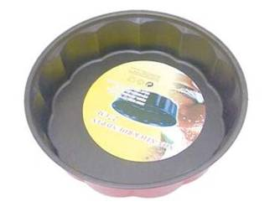 |  | 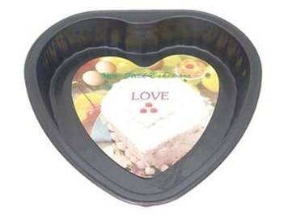
 |  | Y100427A PLUM FLOWER SHAPE CAKE MOLD- metal (thickness 0.4 mm), size: 28x6.5 cm. Teflon coated inside and red lacquer on outer. Weight: 227 g/pc. Packing: 60 pcs/ctn/29x29x34cm/0.0286 cbm.  Q’ty: 10,000 pcs  FOB US$0.85/pc |  | Y100427B HEART SHAPE CAKE MOLD- metal (thickness 0.4 mm), size: 28x6.5 cm. Teflon coated inside and red lacquer on outer. Weight: 185 g/pc. Packing: 100 pcs/ctn/28x28x32 cm/0.025 cbm.  Q’ty: 6,800 pcs  FOB US$0.87/pc
 |  | 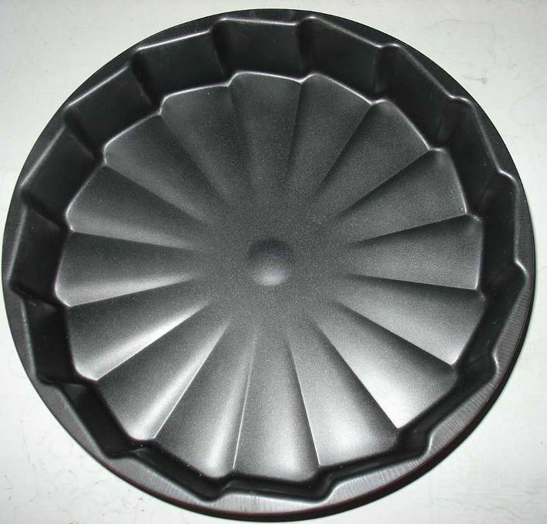
Y100427C WHEEL SHAPE CAKE MOLD- metal (thickness 0.4 mm), size: 28.5x5.5 cm. Teflon coated inside and red lacquer on outer. Weight: 233 g/pc. Packing: 60 pcs/ctn/29x29x30cm/0.0286 cbm.
Q’ty: 10,000 pcs
FOB US$0.94/pc
 | 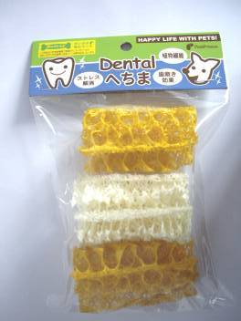 |  |  | 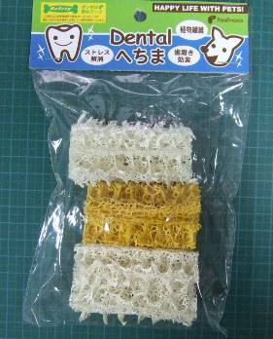
 | 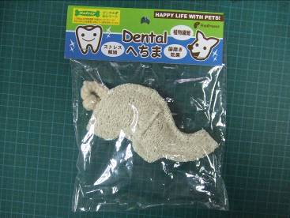 |  |  | 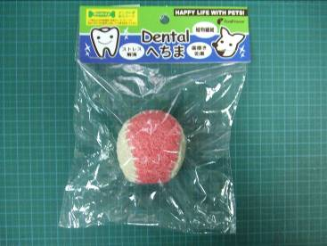
 | 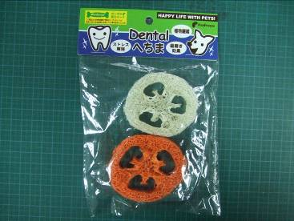 |  |  | 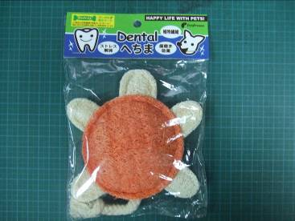
Y100411A PET CHEWING TOYS- made from plant fiber, 5 dift. patterns, mixed colors. Each pc in a PP bag w/header card, two of items are 2 & 3 pcs in a bag. Packing: 100 bags in a carton (abt. 0.057 cbm/ 2.0 cuft.) Features: *Plant fiber definite is a safety toys for pet. *Dental protection for pet, when they chewing this toy meantime have the teeth clean.
Q’ty: 15,000 packs
FOB US$0.63/pack
 | 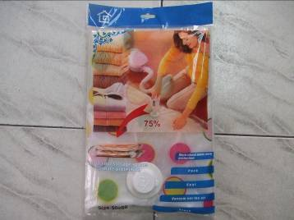 |  |  | 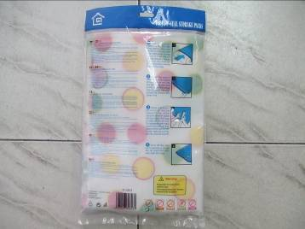
 | 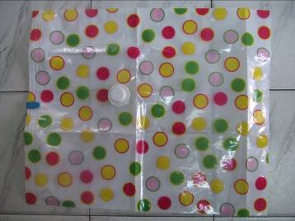 |  |  | 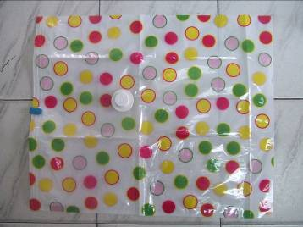
 | 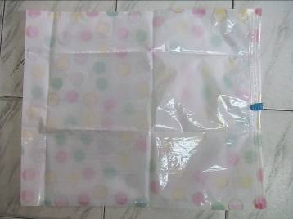 |  |  | 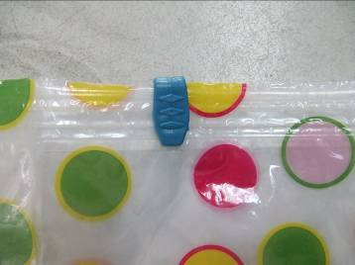
 | 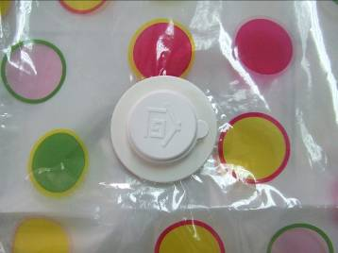 |  |  | 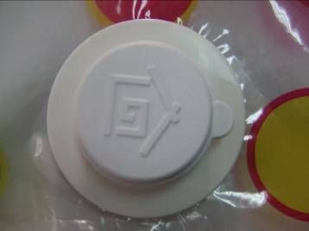
Y100320B VACUUM-SEAL STORAGE PACKS- PP bag 50x60 cm, w/seal and plastic tip (abt. 10 cm for fit the vacuum cleaner). 2 sizes of 50x60 cm & 60x 80 cm. Thickness: 7 si (0.07 mm). 5 dift. printing designs. Packing: each pc in a color printed PP bag, 180 pcs (50x60 cm)/ctn, 150 pcs (60x80 cm)/ctn. Carton sizes are same at 65x35x40 cm (0.091 cbm/3.21 cuft.)
Q’ty: 20,000 pcs (50x60 cm), 10,000 pcs (60x80 cm).
FOB US$0.56/pc (50x60 cm), 0.59/pc (60x80 cm)
 | *Below are the other two available designs.
 | 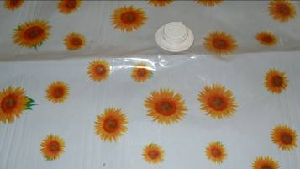 |  |  | 

